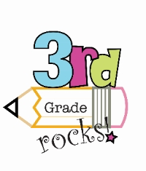

Student Name_____________________________________________

Dear Third Grade Families,

Below you will find your student’s scores for the ________________________ Math test and end of unit Performance Task. Please sign this slip and return to school.

Your Third Grade Teachers,
Sample

Test Score______________

Performance Task Score_______________________

Your student is doing well with…

______________________________________________________________________________________________________________________________________________________________________________________________________________________________
Next time try to work with your student on…
______________________________________________________________________________________________________________________________________________________________________________________________________________________________

Family Signature______________________________________________

